HPV catch up weekend: 21 -22 March 2026
Suggested social media posts

For audiences of young people aged 17-25
(for use with the ‘gamer chat’ graphics)
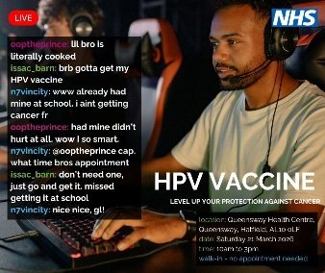 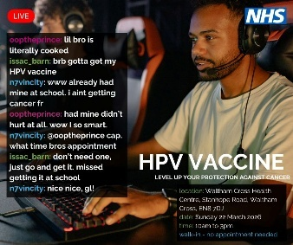 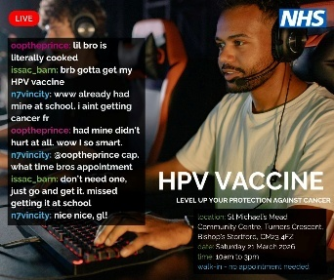 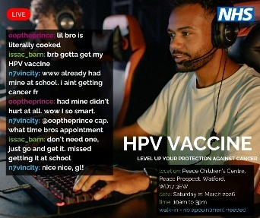
Suggested post copy

Hatfield | “brb getting my HPV vaccine”  “already had mine, didn’t even hurt”  “W move tbh”  Level up your IRL health stats. Missed your HPV jab at school? No stress — you can still get protected.  📍 Queensway Health Centre, Hatfield  📅 Saturday 21 March  ⏰ 10am–3pm  🚶‍♂️ Walk-in, no appointment needed  Protecting yourself from HPV-related cancers is a W. Pull up, get it done, carry on with your day.
Bishop’s Stortford | “brb getting my HPV vaccine”  “already had mine, didn’t even hurt”  “W move tbh”  Level up your IRL health stats. Missed your HPV jab at school? No stress — you can still get protected.  📍 St Michael’s Mead Community Centre, Turners Crescent, Bishop’s Stortford  📅 Saturday 21 March  ⏰ 10am–3pm  🚶‍♂️ Walk-in, no appointment needed  Protecting yourself from HPV-related cancers is a W. Pull up, get it done, carry on with your day.
Watford | “brb getting my HPV vaccine”  “already had mine, didn’t even hurt”  “W move tbh”  Level up your IRL health stats. Missed your HPV jab at school? No stress — you can still get protected.  📍 Peace Children’s Centre, Peace Prospect, Watford  📅 Saturday 21 March  ⏰ 10am–3pm  🚶‍♂️ Walk-in, no appointment needed  Protecting yourself from HPV-related cancers is a W. Pull up, get it done, carry on with your day.
Waltham Cross | “brb getting my HPV vaccine”  “already had mine, didn’t even hurt”  “W move tbh”  Level up your IRL health stats. Missed your HPV jab at school? No stress — you can still get protected.  📍 Waltham Cross Health Centre, Stanhope Road, Waltham Cross  📅 Sunday 22 March  ⏰ 10am–3pm  🚶‍♂️ Walk-in, no appointment needed  Protecting yourself from HPV-related cancers is a W. Pull up, get it done, carry on with your day.

For audiences of young people aged 17-25
(for use with the ‘general’ graphics)
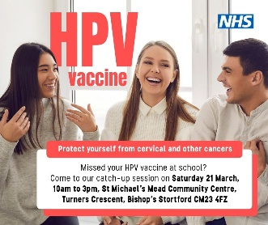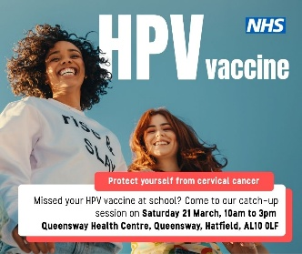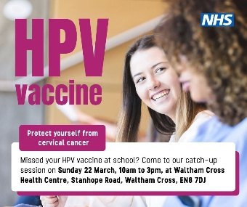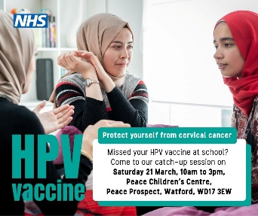

Hatfield | The HPV vaccine protects against several cancers, and it’s free if you’re under 25. If you didn’t get the vaccine in Year 8, you can still get it now.  📍 Queensway Health Centre, Hatfield  📅 Saturday 21 March  ⏰ 10am–3pm  🚶‍♂️ Walk-in, no appointment needed  Walk-in, free, and done in minutes.
Bishop’s Stortford | The HPV vaccine protects against several cancers, and it’s free if you’re under 25. If you didn’t get the vaccine in Year 8, you can still get it now.  📍 St Michael’s Mead Community Centre, Turners Crescent, Bishop’s Stortford  📅 Saturday 21 March  ⏰ 10am–3pm  🚶‍♂️ Walk-in, no appointment needed  Walk-in, free, and done in minutes.
Watford | The HPV vaccine protects against several cancers, and it’s free if you’re under 25. If you didn’t get the vaccine in Year 8, you can still get it now.  📍 Peace Children’s Centre, Peace Prospect, Watford  📅 Saturday 21 March  ⏰ 10am–3pm  🚶‍♂️ Walk-in, no appointment needed  Walk-in, free, and done in minutes.
Waltham Cross | The HPV vaccine protects against several cancers, and it’s free if you’re under 25. If you didn’t get the vaccine in Year 8, you can still get it now.  📍 Waltham Cross Health Centre, Stanhope Road, Waltham Cross  📅 Sunday 22 March  ⏰ 10am–3pm  🚶‍♂️ Walk-in, no appointment needed  Walk-in, free, and done in minutes.

Aimed at parents
(for use with the ‘parents’ graphics)
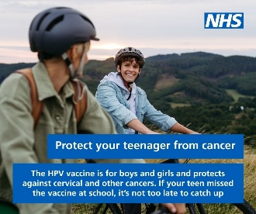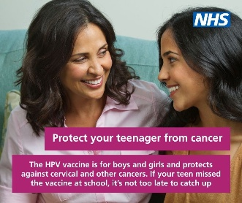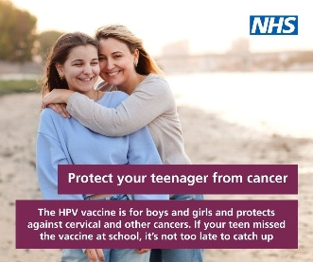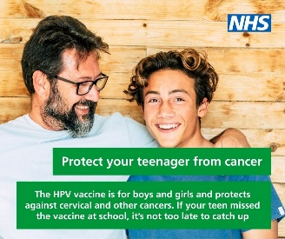
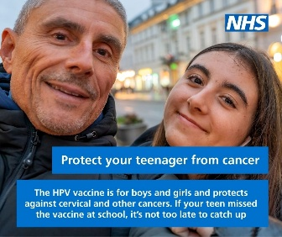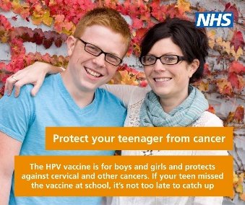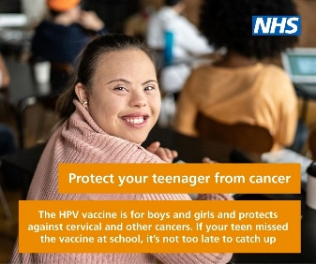
Hatfield | Protecting your child’s health is one of the most important things you can do. If they missed their HPV vaccine at school, there’s a chance to catch up. The HPV vaccine protects against cervical and other cancers and is free up to age 25.  📍 Queensway Health Centre, Hatfield  📅 Saturday 21 March  ⏰ 10am–3pm  No appointment needed — just walk in.
Bishop’s Stortford | Protecting your child’s health is one of the most important things you can do. If they missed their HPV vaccine at school, there’s a chance to catch up. The HPV vaccine protects against cervical and other cancers and is free up to age 25.  📍 St Michael’s Mead Community Centre, Turners Crescent, Bishop’s Stortford  📅 Saturday 21 March  ⏰ 10am–3pm  🚶‍♂️ Walk-in, no appointment needed
Watford | Protecting your child’s health is one of the most important things you can do. If they missed their HPV vaccine at school, there’s a chance to catch up. The HPV vaccine protects against cervical and other cancers and is free up to age 25.  📍 Peace Children’s Centre, Peace Prospect, Watford  📅 Saturday 21 March  ⏰ 10am–3pm  🚶‍♂️ Walk-in, no appointment needed
Waltham Cross | Protecting your child’s health is one of the most important things you can do. If they missed their HPV vaccine at school, there’s a chance to catch up. The HPV vaccine protects against cervical and other cancers and is free up to age 25.  📍 Waltham Cross Health Centre, Stanhope Road, Waltham Cross  📅 Sunday 22 March  ⏰ 10am–3pm  🚶‍♂️ Walk-in, no appointment needed

