Festive messages
Newsletter/website content
Stay well this festive season
The local NHS is asking people across the area to use the right service at the right time if they do need medical help over the Christmas and New Year.
Health and care teams across Hertfordshire and west Essex will be working around the clock to look after people as local communities celebrate the festive period and also ring in the New Year, with a range of services also open over the two Bank Holidays.
For urgent support with non-emergency medical issues, visit 111.nhs.uk or call 111. NHS 111 can offer you advice and help you get seen by the right NHS service if you need medical attention. Minor issues like sprains, cuts, or scalds can be treated at local Minor Injury Unit or Urgent Treatment Centre located in Welwyn Garden City, St Albans, Watford, Hemel, Stevenage, Cheshunt, Bishop’s Stortford and Harlow. For details about services available, visit https://www.hertsandwestessex.ics.nhs.uk/your-health-and-care/support/urgent/
For the NHS, the first week of January is historically one of the busiest of the year, partly as a result of seriously ill people putting off seeking help over the bank holidays. If you or a loved one are very ill at Christmas or the new year, get medical advice straight away. Early help can prevent hospital admissions and save lives.
Many community pharmacies are open over the Christmas and New Year, offering advice and treatment for minor illnesses and injuries. Through Pharmacy First, pharmacists can issue medication for common conditions like sore throats and UTIs, without a GP prescription.
If you catch a common winter bug like COVID-19 or flu, you can often look after yourself safely at home. Getting plenty of rest and taking over-the-counter medications such as ibuprofen or paracetamol can help you look after your health if you do feel poorly over the New Year.
Winter can evoke contrasting emotions: some look forward to festive joy, while others face mental health challenges. The NHS is here for you and support is available 24/7 for anyone who is struggling. A range of confidential support services are available throughout the festive season, including Christmas Day and New Year's Day. There are NHS Mental Health Crisis Lines: Call 111 and select the mental health option for 24/7 urgent support. Or you can contact Samaritans who offer a free, confidential, 24-hour listening service for anyone who needs to talk. Call 116 123 or visit their website at samaritans.org.
More information at www.hertsandwestessex.ics.nhs.uk/winter
Social media
Post wording | Asset | Alt text
Your local pharmacy can help you with lots of different issues, from giving advice and treatment for common illnesses to answering questions about your medication.  Visit www.nhs.uk/find-a-pharmacy to find a pharmacy near you. | 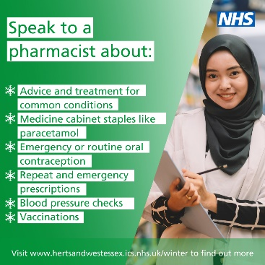 | Photo shows a member of pharmacy staff. Text reads: Speak to a pharmacist about advice and treatment for common conditions; medicine cabinet staples like paracetamol; repeat and emergency prescriptions; blood pressure checks; vaccinations.  Visit www.hertsandwestessex.ics.nhs.uk/winter to find out more
Please order any repeat prescriptions for medications you use in good time, so you don’t run out over the bank holidays.  You can order your prescription via the NHS App, through your GP practice website in many cases, or by contacting your practice. | 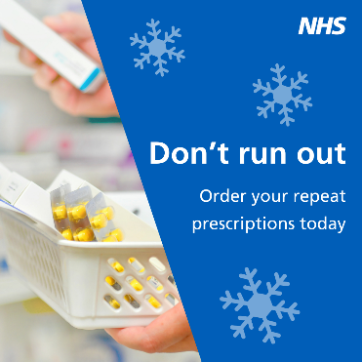 | Photo shows member of pharmacy staff collecting medication. Text reads: Don’t run out – order your repeat prescriptions today.
Do you have an urgent medical problem that’s not an emergency?  NHS 111 can help by giving you advice on how to look after yourself at home or getting seen by the right service if you need medical attention.  Visit 111.nhs.uk or call 111, 24/7, every day of the year. | 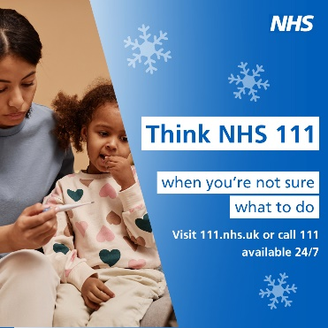 | Photo shows a woman holding a child who is poorly and is checking her temperature. Text reads: Think NHS 111 first when you’re not sure what to do.  Visit 111.nhs.uk or call 111 – available 24/7
Did you know most pharmacies can now offer you treatment for seven common conditions, without you needing to see a GP first?  Through Pharmacy First you can get help for illnesses like sinusitis and sore throat. Visit www.nhs.uk/find-a-pharmacy to find a pharmacy near you. | 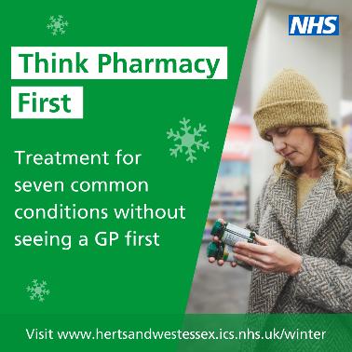 | Photo shows a woman in a pharmacy looking at product. Text reads: Think pharmacy first – treatment for seven common conditions without seeing a GP first. Visit www.hertsandwestessex.ics.nhs.uk/winter
The NHS will be here for you throughout the holiday season.  Visit www.hertsandwestessex.ics.nhs.uk/winter to find the right service for your needs. | 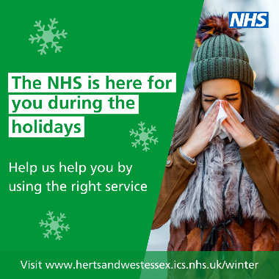 | Photo shows a woman outside, wearing warm clothing, blowing her nose. Text reads: The NHS is here for you during the holidays. Help us help you by using the right service. Visit www.hertsandwestessex.ics.nhs.uk/winter
Your local Minor Injury Units and Urgent Treatment Centres are open during some or all the holiday season.  They can help with a range of issues including sprains, wounds and cuts, and minor burns – no appointment needed.  Find your nearest location via www.hertsandwestessex.ics.nhs.uk/winter | 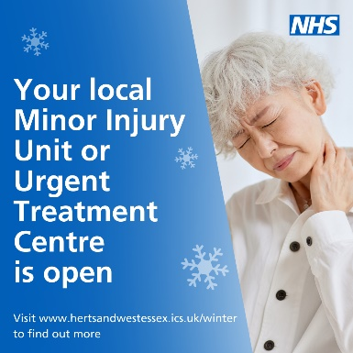 | Photo shows a person holding their neck as if to suggest it’s hurting. Text reads: Your local Minor Injury Unit or Urgent Treatment Centre is open.  Visit www.hertsandwestessex.ics.nhs.uk/winter to find out more
If you’ve got a minor illness like a cold or upset stomach, you can often look after yourself safely at home.  Make sure you have a well-stocked medicine cabinet with things like paracetamol and indigestion remedies to help treat minor issues from the comfort of your own home. | 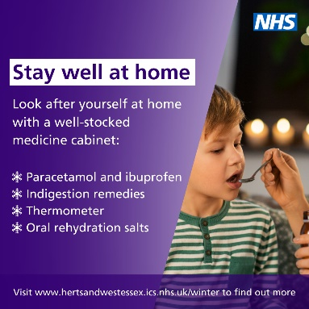 | Photo shows a woman giving medicine to a child on a spoon. Text reads: Stay well at home. Look after yourself at home with a well-stocked medicine cabinet: Paracetamol and ibuprofen; indigestion remedies; thermometer; oral rehydration salts. Visit www.hertsandwestessex.ics.nhs.uk/winter to find out more
Make sure you have a well-stocked first aid kit with things like plasters, antiseptic wipes, and tweezers, so that you can stay well at home if you have a minor injury.  Visit www.hertsandwestessex.ics.nhs.uk/winter to find out more. | 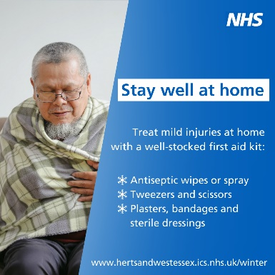 | Photo shows a man looking poorly, wrapped in a blanket. Text reads: Stay well at home – treat mild injuries at home with a well-stocked first aid kit: Antiseptic wipes or spray; tweezers and scissors; Plasters bandages and sterile dressings. Visit www.hertsandwestessex.ics.nhs.uk/winter
Your local Minor Injury Unit or Urgent Treatment Centre can help you with many different issues – from wounds and cuts to minor burns and scalds – no appointment needed.  Find your nearest location via www.hertsandwestessex.ics.nhs.uk/winter | 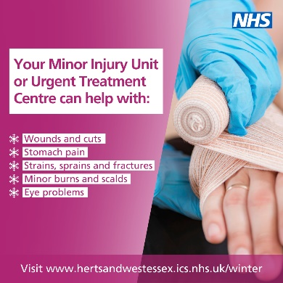 | Photo shows a hand being wrapped up in a bandage. Text reads: your minor injury unit or urgent treatment centre can help with: wounds and cuts; stomach pain; strains, sprains and fractures; minor burns and scalds; eye problems. Visit www.hertsandwestessex.ics.nhs.uk/winter to find out more
Please help us help you by only using A&E if you have a genuine life or limb-threatening emergency.  If you come to A&E with an issue that is not an emergency, you may experience a very long wait or be asked to go to another service.  Please use the right service so we can help those most in need. | 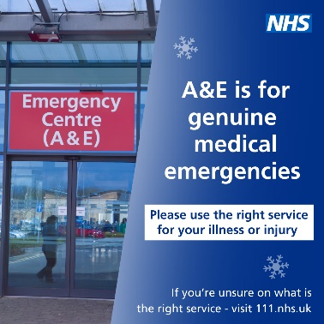 | Picture shows an A&E department sign. Text reads: A&E is for genuine medical emergencies. Please use the right service for your illness or injury. If unsure on what is the right service, visit 111.nhs.uk
The holidays are a festive time for many, but we know it can also be a difficult period for lots of us.  If you’re struggling with your mental health, you’re not alone and help is available.  Visit www.hertsandwestessex.ics.nhs.uk/winter to find support near you. | 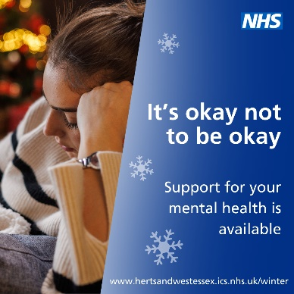 | Photo shows a woman sitting down on a sofa with a blanket over her, in front of a Christmas tree. Text reads: it’s okay not to be okay. Support for your mental health is available. Visit www.hertsandwestessex.ics.nhs.uk/winter
Thank you to all health and care staff in Hertfordshire and west Essex who are working over the holidays to look after local people. | 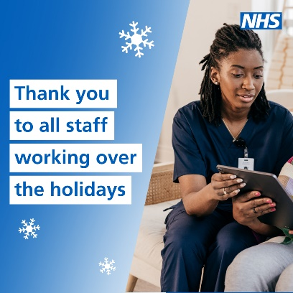 | Photo shows a health worker in scrubs next to a woman on a sofa. Text reads: Thank you to all staff working over the holidays
As we get ready to ring in the New Year, we want to say a big thank you to all health and care staff across the area who are working today to look after local people. | 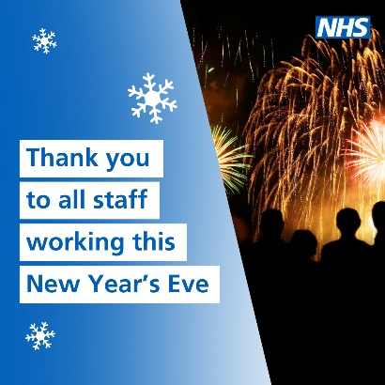 | Photo shows people watching fireworks overhead. Text reads: Thank you to all staff working this New Year’s Eve

