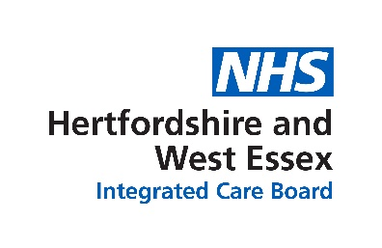

Only order what you need
Campaign toolkit
November 2025

Aim of campaign
The main aim is to help reduce the number of repeat prescription orders that are not needed in Hertfordshire and west Essex.
To do this we want to provide clear and succinct advice to the public about the need to reduce medicine waste, the importance of only ordering medicines that are needed and the implications of over ordering from repeat prescriptions.
It is beneficial to the NHS as by saving money on unused medicines we can invest in other services to improve outcomes for our population. There are also safety issues with stockpiling medicines and an environmental impact from the waste.

Audience
- The primary audience is patients who have repeat prescriptions
- Secondary audiences those aged over 65 who are taking multiple repeat medications

Key messages
- Approximately one in every ten medicines handed out are not needed or wanted.
- Around £7.5 million is wasted in Hertfordshire and west Essex each year on unused medicines. This included inhalers, pain medication and creams. By only ordering what we need we can make sure NHS resources go where they are most needed. We need your help to achieve this.
- Unused medicines go out of date and might not work as intended, meaning your care might be compromised
- Find out what your medicines are for and what are what are the risks and benefits of taking them. More information can be found on the NHS Health A-Z website, or ask your healthcare professional for advice.
- Check what medicines you already have at home before you order more.
- Tell your healthcare professional if you stop taking your medication or if you are receiving medicines you don’t use.
- Medicines are only prescribed for you, and it is not safe to share prescribed medicines with anyone else.
- Stockpiling medicines worsens medicines shortages so people who really need them cannot get them.
- Stockpiles of medicines kept at home can be dangerous for children and pets.
- When you dispose of medicines properly, by handing them in to your pharmacy, you are helping to make sure that waste medicines do not pollute our rivers and seas.
- Only ordering what you need means that you are helping the environment because once medicines have left the pharmacy, they cannot be recycled or used by anyone else.
Call to action
- Check what medicines you already have at home and ONLY ORDER WHAT YOU NEED.
- Visit www.hertsandwestessex.ics.nhs.uk/meds or speak to your Pharmacy or General Practice to find out more.
- Take control of your medicines ordering and use the NHS App to order repeat medicines if you have a smartphone.

What the ICB is doing
The campaign has been shared with pharmacies and general practice in the area who have been encouraged to support the messaging beyond the communications activity and will be, where possible, looking at ways to maximise the efficiency of the repeat prescription ordering process, sharing the messages with their patients and with their local networks.
Using a small budget the ICB will also be delivering a digital and print campaign through the following activities:
Activity | Detail
Posters and leaflets | Shared with all pharmacies, GP practices in the area
Facebook advertising | Pushing out some paid for advertising on the ICB Facebook page to increase reach
Digital display advertising | 4 weeks paid for campaign across partner channel websites with banner displays linking to ICB website
Radio advertising | 4 weeks advertising on Global radio network targeting adults over 25 years old in the HWE area
Events | Taking leaflets and other information to events where possible locally, often tied in to Blood Pressure checks campaign at OPALS events
ICB channels | Sharing messages across ICB channels and networks
Media | Media release to local media

Materials for partners to use
Included in this pack there are a variety of tools. If there is something that anyone needs, they can contact the ICB communications team for advice on Hweicbenh.communications@nhs.net
  - News piece
  - News piece shorter
  - Social media messages
  - Display screen images portrait and landscape
  - Leaflets that can be printed
  - Posters that can be printed

Toolkit

News piece
Tackling medicine waste – only order what you need
Did you know that 1 in 10 medicines given out aren’t needed or used? In Hertfordshire and west Essex, £7.5 million is wasted every year on unused medicines like inhalers, painkillers, and creams. That’s why the local NHS is encouraging everyone to check before they order to help the NHS spend money where it’s needed the most.
Ordering medicines when they aren’t needed can mean you end up with more than you need in your cupboard. Small changes in managing our medicines can make a big difference and help reduce medicine waste. Medicine waste and throwing medicines away incorrectly not only costs money but also harms the environment. Help us to stop waste and check what medicines you have at home before you place an order and only order the medicines you actually need.
Anurita Rohilla, Chief Pharmacist at NHS Hertfordshire and West Essex Integrated Care Board, said: “This campaign isn’t just about saving money. It’s about making sure patients get the care they need, protecting our NHS, and helping the environment.
“When medicines go unused, it’s a missed chance to help someone — and it costs our communities. We know it can be tricky to manage prescriptions, especially if you take several. But small steps can help, like checking what you already have before ordering more, or speaking to your pharmacist if you’ve stopped taking something.
“We’re asking everyone in Hertfordshire and west Essex to get involved. Whether you’re a patient, a carer, or work in healthcare, we all have a role in cutting down medicine waste.
“Let’s work together to make sure medicines are used safely and wisely. If you’re unsure about a medicine or don’t need it anymore, talk to your healthcare professional — we’re here to help. We want you to get the full benefit from your treatment. If you can take your medicine, please do. If you can’t, let us know.”
The campaign also reminds people to check their prescriptions when collecting them from the pharmacy. If any items are no longer needed, inform the pharmacy team before leaving, so the medicine can potentially be reused for others. Additionally, it is vital to return any unused or out of date medicines to a pharmacy for safe disposal. Storing large quantities of medication at home poses a danger, particularly to children and pets. Medicines should never be thrown in household waste or flushed down the toilet, as this can cause serious harm to the environment.
Order your medication when you are running low (7to 10 days before you need them), and no earlier. You can add reminders in your calendars to help you check to see if you need to order more.
If you take regular medicines ask your GP practice for a medication review if you haven’t had one in the last year or if you have questions about the medicines prescribed for you Tell your healthcare professional if you’ve stopped taking any medicines or have concerns about them. Keep a list of all the medicines you take so you can show it to a healthcare professional when they are discussing your care and treatment with you

Together, we can reduce waste, support better patient care, and help protect the planet.
Find out more at www.hertsandwestessex.ics.nhs.uk/meds

News piece shorter
A short 150 words if required for print publications:
Only order what you need
Every year, £7.5 million is wasted in Hertfordshire and west Essex on unused medicines like inhalers, painkillers, and creams. That’s why the NHS is asking everyone to check before they order and “Only order what you need”.
Ordering medicines you don’t need can lead to stockpiling, waste, and even environmental harm. Small changes—like checking your cupboard before reordering or speaking to your pharmacist if you’ve stopped taking something—can make a big difference.
Unused medicines are a missed opportunity to help someone else and put pressure on NHS resources. If you’re unsure about a prescription or don’t need it anymore, ask your healthcare professional for advice. Return any unused or expired medicines to your pharmacy for safe disposal - never throw medicines in the bin or down the toilet.
Find out more at www.hertsandwestessex.ics.nhs.uk/meds

GP website news item
Only order what you need
Every year, £7.5 million is wasted in Hertfordshire and west Essex on unused medicines like inhalers, painkillers, and creams. That’s why the NHS is asking everyone to check before they order and “Only order what you need”.
Ordering medicines you don’t need can lead to stockpiling, waste, and even environmental harm. Small changes—like checking your cupboard before reordering or speaking to your pharmacist if you’ve stopped taking something—can make a big difference.
Unused medicines are a missed opportunity to help someone else and put pressure on NHS resources. If you’re unsure about a prescription or don’t need it anymore, ask your healthcare professional for advice. Return any unused or expired medicines to your pharmacy for safe disposal - never throw medicines in the bin or down the toilet.
Find out more at www.hertsandwestessex.ics.nhs.uk/meds

GP texts
General text:
1 in 10 med handed out are not needed or wanted. Please only order what you need and check the expiry date on your meds. Questions about your prescription? Please ask in practice or at your pharmacy. More info at: www.hertsandwestessex.ics.nhs.uk/meds
Due repeat:
1 in 10 med handed out are not needed or wanted. Only select the medicines you take when reordering your repeat prescriptions. Please ask in practice or at your pharmacy if you have a question about a medicine you have been prescribed. More info at: www.hertsandwestessex.ics.nhs.uk/meds
Older people on multiple meds:
If you are taking multiple medicines then only reorder the medicines you need each time. Not selecting them doesn’t mean you can’t order them next time. Book in with us for a review if you need one. More info at: www.hertsandwestessex.ics.nhs.uk/meds
Carers:
If you are concerned about the medicines the person you care for is taking then please discuss this with them and if they agree, book in with them for a review. Let us know if they are planning to stop taking any medicines or are concerned about their effects. More info at: www.hertsandwestessex.ics.nhs.uk/meds

Social media messages
Facebook/Nextdoor | Twitter (X) | Image
Did you know that around £7.5 million is wasted every year in Hertfordshire and west Essex on unused medicines — including inhalers, painkillers, and creams?  That’s money that could go towards vital NHS services. We need your help to change this.  ✅ Only order what you need  ✅ Check your medicine cabinet before reordering ✅ Speak to your healthcare professional if you’re receiving medicines you don’t use  ✅ Never share prescribed medicines — they’re just for you  Together, we can make sure NHS resources go where they’re most needed. Let’s protect our health, our environment, and our community. | 💊 1 in 10 medicines go unused. That’s £7.5 million wasted each year in Herts & West Essex. ✅ Only order what you need 🗣 Speak to your healthcare professional. Let’s protect NHS resources & your health. #OnlyOrderWhatYouNeed | 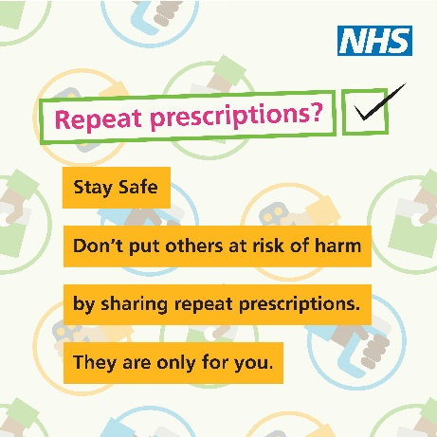
One in ten medicines handed out aren’t needed or wanted. That’s not just waste — it could compromise your care.  Be medicine smart:  🗣 Information about your medicines can be found on the NHS Health A-Z website, or ask your healthcare professional for advice  📦 Check what you already have before ordering more  🚫 Tell your doctor if you’ve stopped taking something  👶 Keep medicines out of reach of children and pets  Your voice matters. Your choices matter. Let’s make every prescription count. | Not sure what your meds are for? Ask! 📦 Check before reordering 🚫 Don’t share prescriptions 🧒 Keep meds away from kids & pets Your choices matter. Make every prescription count. #SafePrescribing #OnlyOrderWhatYouNeed | 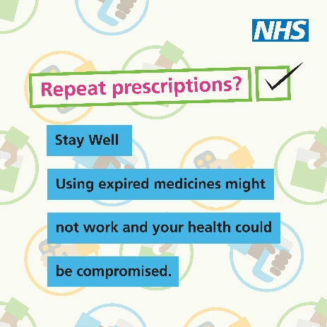
Every medicine counts — for your health and for our planet.  Once medicines leave the pharmacy, they can’t be reused or recycled. Unused medicines often end up polluting our rivers and seas if not disposed of properly.  Here’s how you can help:  🔹 Return unused medicines to your pharmacy  🔹 Avoid stockpiling — it worsens shortages and can be dangerous for children and pets  🔹 Only order what you truly need  Let’s protect our environment while making sure NHS resources go where they’re needed most. | Unused meds = wasted money + polluted rivers 🌊 Once they leave the pharmacy, they can’t be reused. ✔ Return unused meds to your pharmacy ✔ Don’t stockpile ✔ Order only what you need #OnlyOrderWhatYouNeed | 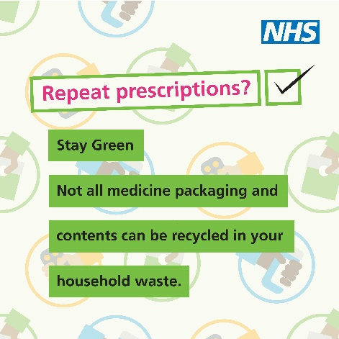

Display screens

Portrait version
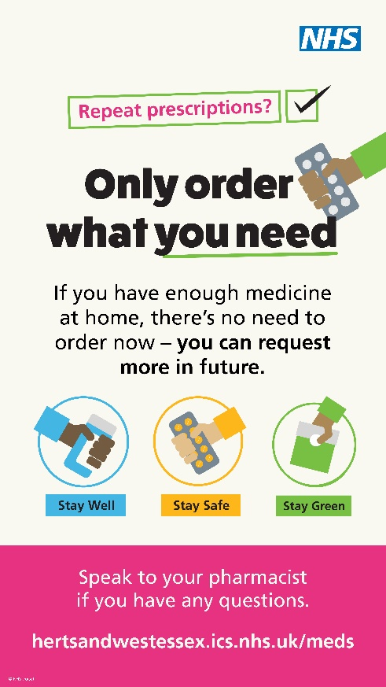
Landscape version
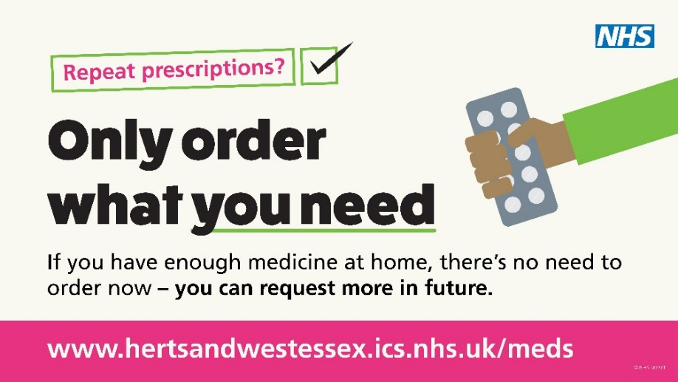

Leaflet that can be printed
A small number of leaflets will be printed and sent to pharmacies and practices; a small additional number are available if needed. Please email hweicbenh.communications@nhs.net

Poster that can be printed
A small number of posters will be printed and sent to pharmacies and practices; a small additional number are available if needed. Please email hweicbenh.communications@nhs.net

