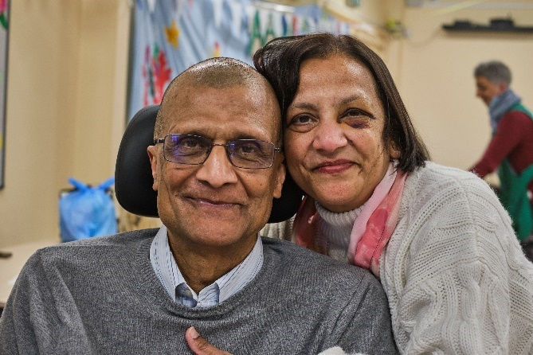
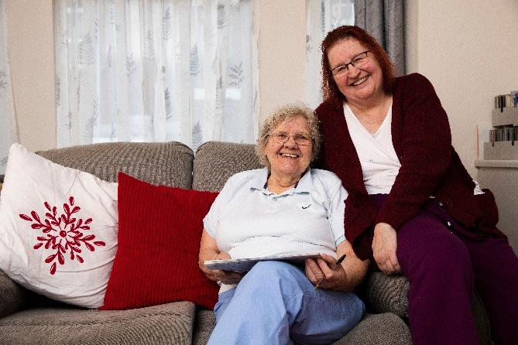

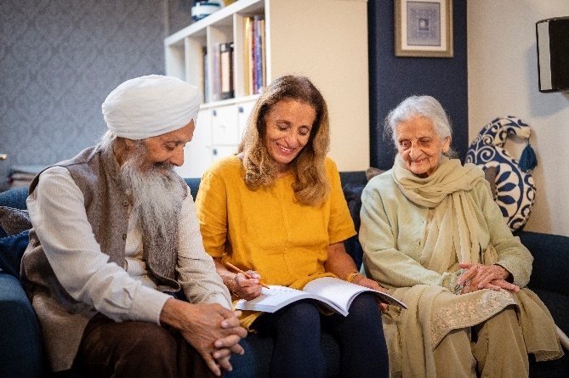
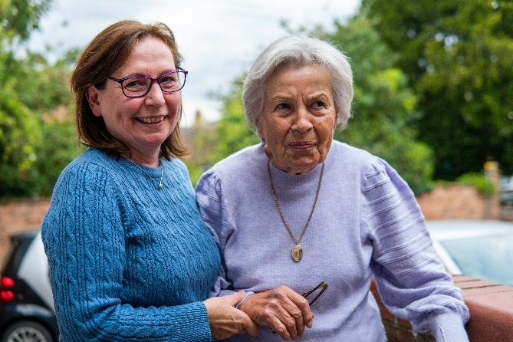
Ageing well and frailty
Public Communications Toolkit

Contents
How to use this toolkit
Volunteer training guide
Factsheet
Articles for newsletters
Q&A with a Frailty Clinician
Social media graphics and copy
Links to resources
Integrated Neighbourhood Teams leaflet

How to use this toolkit
This communications toolkit is designed to support you and your organisation in sharing clear, consistent, and accessible messages about frailty with your networks. It brings together key information, ready-to-use materials and suggested messages to help you communicate with confidence and impact. You can choose to use the elements of this toolkit that match the channels that you have, for example, if your organisation doesn’t use social media, but you have a website, you may wish to use our social media content on your webpages instead.
If you have questions about the toolkit, or suggestions for future updates, please email: susan.haigh1@nhs.net

Volunteer training guide
As a volunteer, you play an important role in:
✅ Helping people understand how to access the right NHS services.
✅ Encouraging conversations about care planning and medicines.
✅ Supporting patients and their families to make informed choices.
You don’t need to be a medical expert - just friendly, approachable, and ready to signpost people to the right services.
How to start a conversation
👋 Approach people with a friendly greeting:
"Hello! I’m [Your Name], a volunteer with [X]. We’re sharing information about how to get NHS care at the right time and place. Would you like a quick chat?”
If they say yes, ask:
“Are you looking for advice for yourself, or do you support an older family member?”
(Adapt what you say based on their answer)
Key messages and talking points
Messages for all
Help is always available
- If you feel unwell, don’t wait. Ask for help early to stay well.
- There are different places to get care including your pharmacy, GP practice and NHS 111
For older people | For those with older family members
Hospital isn’t the only option  - Being treated at home can be more comfortable than a hospital stay.  - Ask if there are ways to get care at home instead of going into hospital. | Hospital isn’t the only option  - Even a short hospital stay can reduce someone’s mobility and independence.  - Ask if home care options like ‘hospital at home’ or ‘virtual wards’ are available for your family member or friend.  - If your family member is admitted to hospital, ask what’s needed to get them home safely as soon as possible.  - Talk about care preferences sooner rather than later. Understanding your parents’ wishes now can prevent stress later.
Make your wishes known  - Talk to your family and your GP or other healthcare professional about what you want in your future care.  - Writing your wishes down helps  healthcare professional and carers know what’s important to you. | Plan ahead for their care  - Talk to your older family members about what care they would want if they became seriously unwell.  - Advance Care Planning ensures their wishes are recorded and respected.
Check your medicines  - If you take medicines, it’s good to check with your healthcare professional that they are still right for you.  - If you are taking a medication it is important to know what you are taking it for.  - Take medicines exactly as your healthcare professional advises. It’s okay to ask if you are unsure.  - Only order medicines when you need them. | Review medications together  - Many older people take multiple medications - help them check they are still needed.  - A medication review with a healthcare professional can ensure medicines are safe and effective.

How to end the conversation
📄 Offer a leaflet:
"Would you like to take a leaflet with more details on these services?"
💬 Encourage them to take action:
"Remember, it’s always okay to ask a healthcare professional about your care or medication!"
😊 Thank them for their time:
"Thanks for chatting with me today, take care!"

Handling common questions
“What if I can’t get a GP appointment?”
✔️ Keep trying. GP practices release appointments at different times. Ask a family member or friend if you need help with contacting your practice online...
“How do I start a conversation about care planning?”
✔️ Start with simple questions like ‘If you were unwell, would you prefer to be treated at home, whether that be your own house or a care home, or in hospital?’
❓ “How do I get a medicine review?”
✔️ Ask your healthcare professional. They can check if all medicines are still needed.
❓ “Where can I get more information?”
✔️ Visit the NHS website, the ICB website, Age UK’s website, or speak to your healthcare professional.
Volunteer tips
✅ Do
✔️ Be friendly and approachable
✔️ Listen and respond to the person’s needs
✔️ Keep messages simple and clear
✔️ Adapt to who you’re talking to. Keep it simple for older adults and practical for carers.
✔️ Encourage people to take action. Small steps like talking to a pharmacist or planning ahead can make a big difference.

🚫 Don’t
❌ Give medical advice - direct people to their healthcare professional instead.
❌ Pressure anyone to talk if they’re not interested.
❌ Overload people with too much information - keep it simple. They can take information away to read in their own time

Factsheet
To be handed out at events following a conversation. Download it here in Word and PDF format.
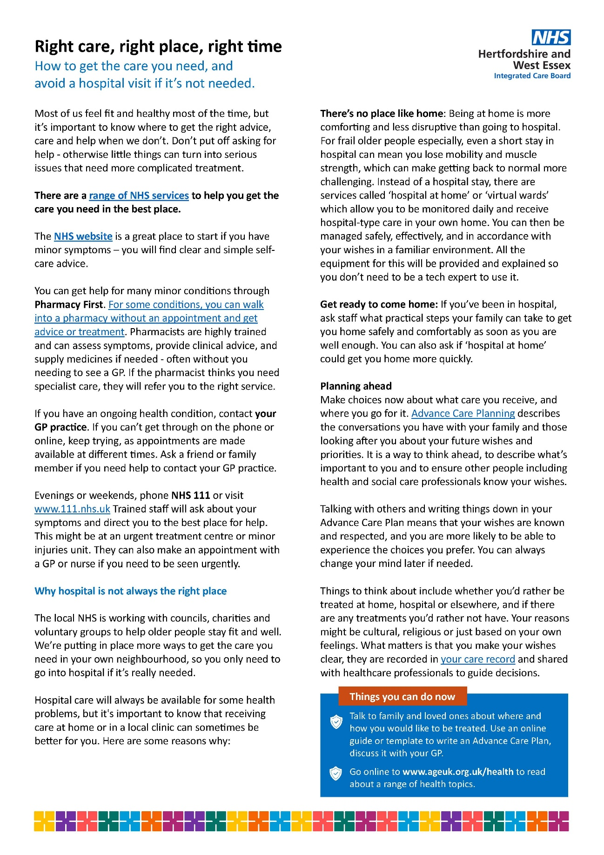

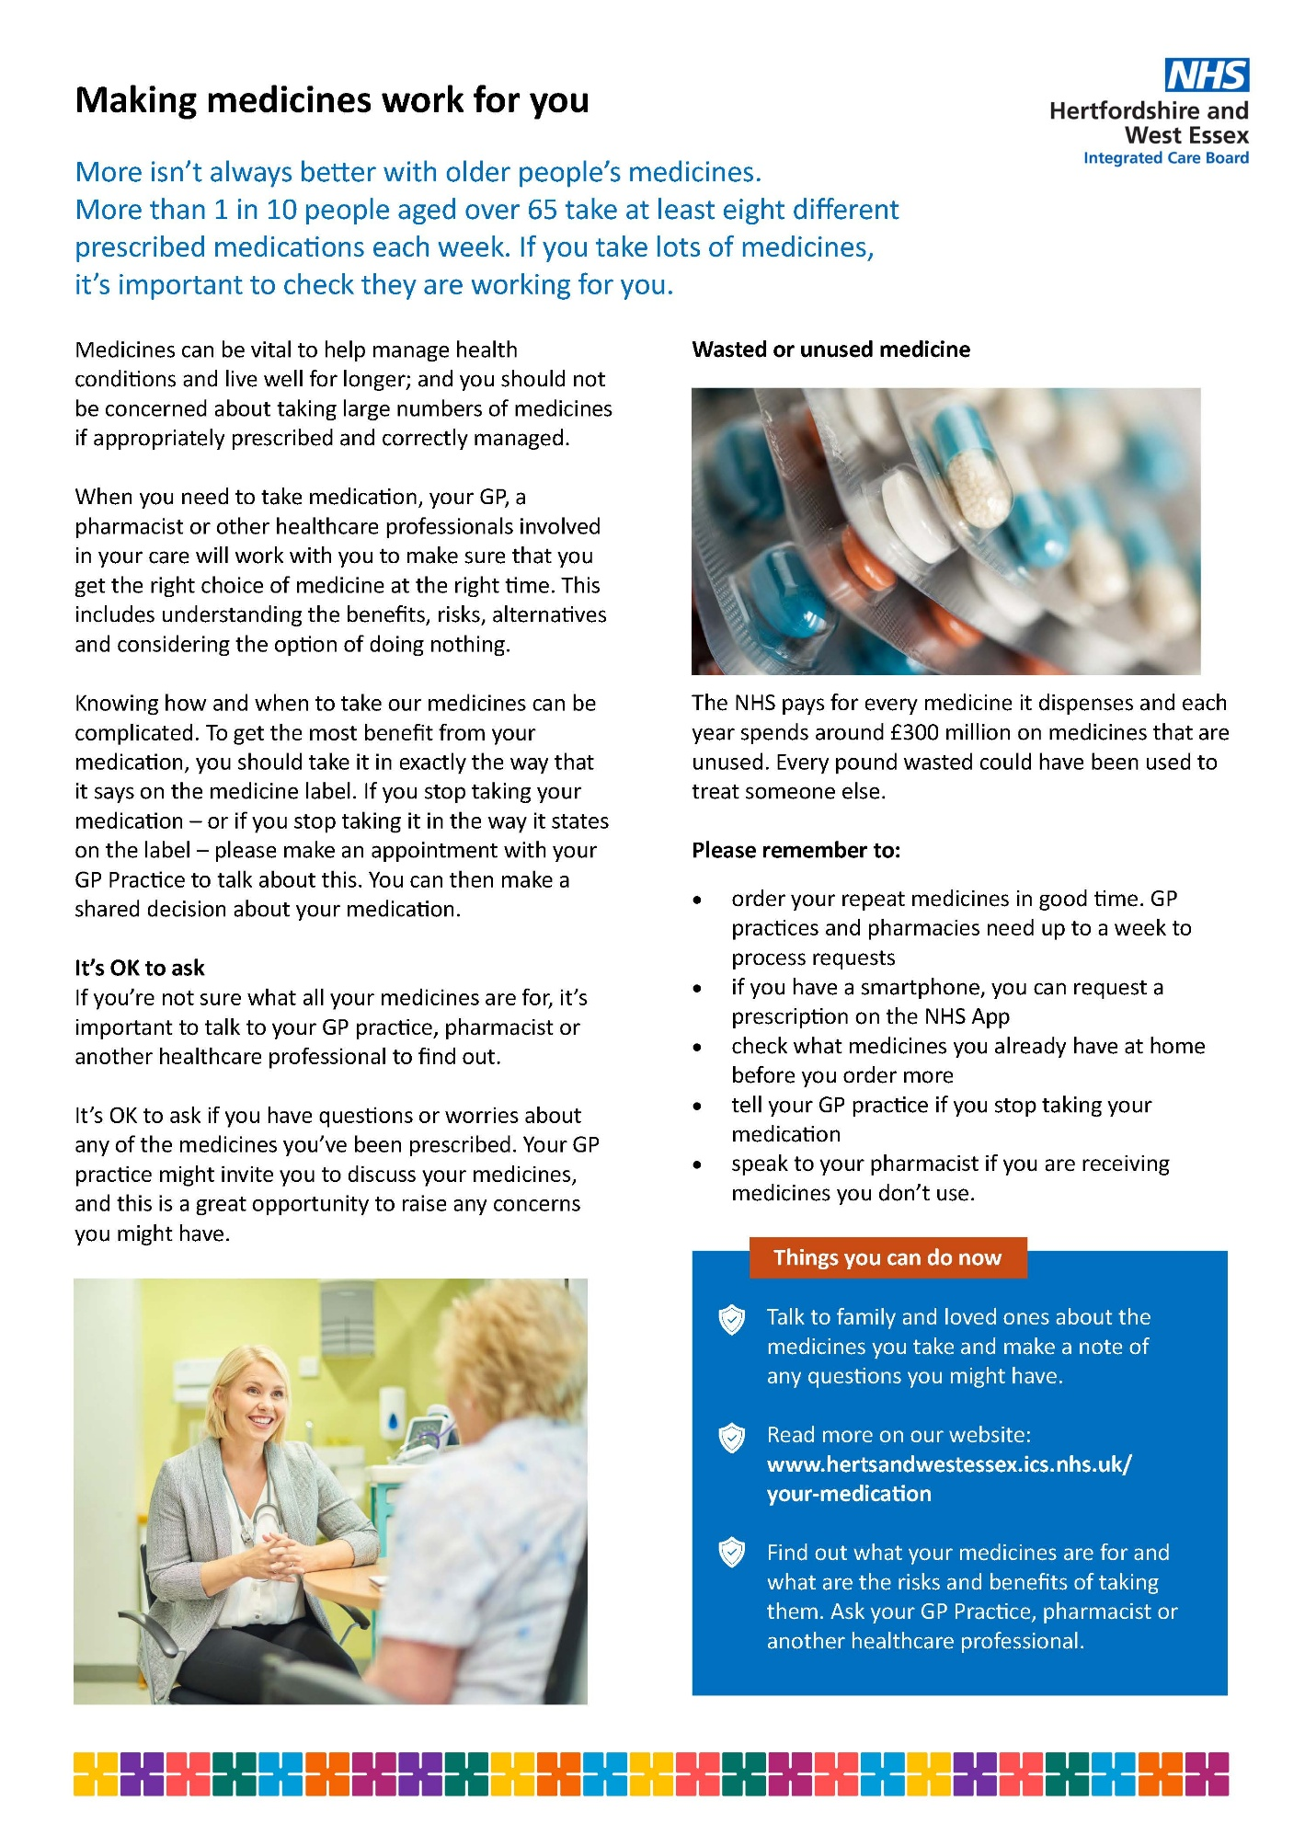

Articles for newsletters

Planning ahead for your care – conversations that matter
Dr Rob Mayson, a local GP explains the importance of talking to family or close friends about your future care needs:
“We want to make sure that all patients in the NHS get the care that is right for them. This is especially true for all of us as we get older or whenever we become unwell. Too often, we see that people’s wishes are not met towards the end of their life, which can be upsetting for them and their families.
“It can help to think ahead about what kind of care you would want if you got very sick. For example, would you always want healthcare professionals to try everything to keep you alive, even if it might not work? Or would you prefer care that focuses on keeping you comfortable?
“There are no right or wrong answers - it’s about what feels best for you. But it’s important that the health and care teams looking after you know your wishes to ensure the right decisions are made. Take some time to talk to your family or those you ae close to about how you might want to be looked after as you get older.
“It’s also a good time to think about the medicines you take. Do they still help you? Do you feel like you need them all? Sometimes, as we get older, some medicines may not be as helpful anymore. You can review them together with your GP, a pharmacist or another healthcare professional if you have any questions.
“You don’t have to decide anything right now. But it’s good to talk about these things with your family. If you’d like to chat more about it, your GP practice is here to help. You can bring it up at your next appointment or let your practice know if you’d like to talk sooner.
“We want everyone to feel comfortable having these conversations, and we believe it should be normal to start thinking about it at a younger age way before ill-health is even a consideration.”
Find out more on the Age UK website
www.hertsandwestessex.ics.nhs.uk/age-well
(355 words)

Q&A with a Frailty Clinician
Helping older family to stay well
Caring for parents or older family members as they age can feel overwhelming, but small steps can make a big difference. Dr Elizabeth Kendrick, Medical Director at Hertfordshire Community NHS Trust, has supported older adults and their families in her time as a GP with a special interest in older people. With her expertise in frailty care, she shares practical advice on how to help your older family stay well, maintain their independence, and plan for the future.
What key things can I do to help older people I know stay well as they age?
Encourage regular movement - that is one of the best things you can do. We are talking even short daily walks, helping people to maintain strength and balance. We need to make sure people are keeping up to date with their vaccinations, including COVID, flu and pneumonia, and we are looking at how we support good nutrition and hydration as well. Think about social connection, making sure people stay engaged with their friends, community activities, hobbies, these all have a significant impact on overall wellbeing. People in their 50s and 60s can start preparing, doing things like Pilates and tai chi to reduce their risk of falls later, into their 70s and 80s.
How do I know if they are taking the right medicines?
As we get older, we tend to take more medicines for different things. With this we are finding that, with age, some of those medicines might not work quite as well, or they might start causing side effects. So, we encourage people to have regular medication reviews with their GP or other healthcare professional — ideally once a year — just to check everything is still right. If someone seems more tired, dizzy or a bit more confused than usual, it could be the medication, and it is worth getting it looked at. As we age, more of a drug can get into the brain or build up in the body, so something that was fine for years might suddenly start causing problems.
What signs should I look out for that older relatives may need more support?
We need to also keep an eye on how people are moving — their balance, their energy levels. If someone is starting to struggle with everyday things, if they are becoming a bit more forgetful, or just not interested in the things they used to enjoy, that can be a sign they might need a bit more support. We would encourage people to have a conversation with their GP or other healthcare professional - even just bringing it up at their next appointment can make a real difference.
How can I help them plan for their future care?
Encourage people to start having those really important conversations about what matters most to them if they were to become unwell. Would they want to be treated at home if that is possible? Do they have particular wishes around the kind of care they would want? These are things that are much easier to talk about early on. People can be helped to record those preferences - that might be through an Advance Care Plan, which may also include a ReSPECT form, so that when decisions need to be made, everyone is clear, and their wishes can be respected.
What should I do if conversations about future care worries them?
We know these conversations can feel difficult at first, which is completely natural. Start small by asking someone what is important to them, what matters most in their life, rather than diving straight into the details about care. We reassure people that planning ahead does not mean giving up independence, it is actually about staying in control, making sure their wishes are known. Should they wish to do so, they can always change their mind later on.
What can I do if I think older family or friends need more help?
There’s lots of helpful information available - the Age UK website is a great place to start, with practical advice on all sorts of topics. If you are looking to find out what local services or support might be available, you can contact:
Herts Help on 0300 123 4044
info@hertshelp.net
Essex Frontline: https://essexfrontline.org.uk/
01799 618855
info@frontlinerferrals.org.uk
(707 words)

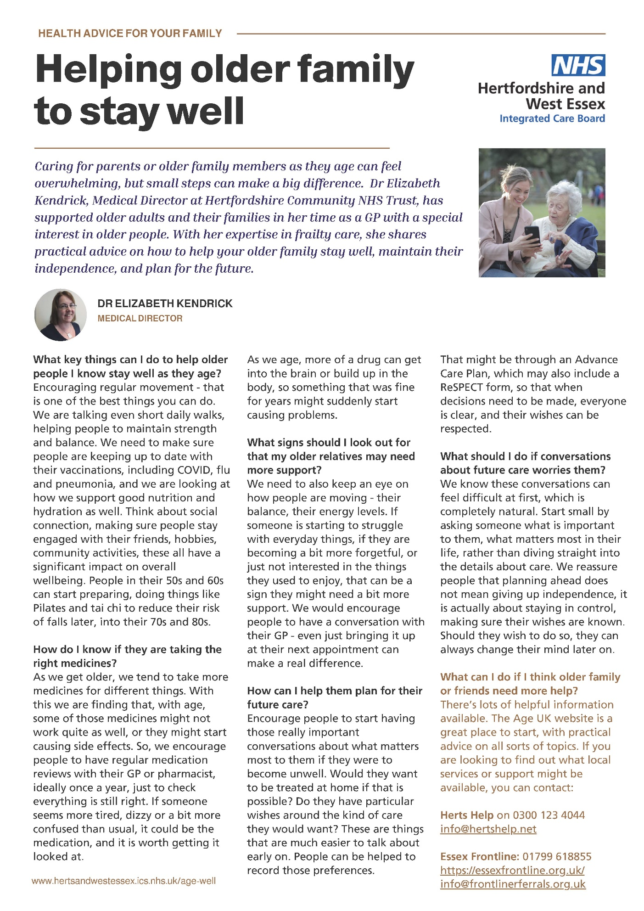
Here is the Q&A text as an A4 magazine-style layout that can be slotted into a newsletter. Download the PDF here.
Social media graphics and copy
Please note that links are included in full, but we assume you’ll use some form of URL shortener, such as https://bitly.com/
Frailty survey (suitable for all platforms)
What do people want from local health care? In a recent survey over 1,000 people told us what's most important to them: read the results here: https://www.hertsandwestessex.ics.nhs.uk/news/new-survey-shows-what-really-matters-to-older-users-of-nhs-services/ Do you agree? What worries you the most, especially as you or family get older?

Medications review (suitable for Facebook or NextDoor)
Taking your medicine is an important part of staying well. Do you know if all your prescriptions are still needed and working effectively? It's OK to ask if you aren't sure: https://www.hertsandwestessex.ics.nhs.uk/your-health-and-care/support/your-medication/ Keep taking all your medicines until you are told to stop or change.
Your GP practice might invite you to discuss your medicines, and this is a great opportunity to raise any concerns you might have. It’s important to take your medicines, and it’s OK to ask if you have any questions. https://www.hertsandwestessex.ics.nhs.uk/your-health-and-care/support/your-medication/
Your GP practice might invite you to discuss your medicines, and this is a great opportunity to raise any concerns you might have. It’s important to take your medicines, and it’s OK to ask if you have any questions. We have a page with lots of information and advice so that you get the help you need https://www.hertsandwestessex.ics.nhs.uk/your-health-and-care/support/your-medication/
If you are 65 or older, your GP or other healthcare professional might invite you for a medication review. This a chance to look at all the medicines you are taking, to see that they are still working and what any alternatives might be. A medication review is an important part of staying well. It's your chance to ask questions or share worries about your medicines. This video tells you more about the review. You can also find out more on our page https://www.hertsandwestessex.ics.nhs.uk/your-health-and-care/support/your-medication/ Keep taking all your prescribed medication until you've had a chance to discuss it with your healthcare professional.

Alternatives to admission (suitable for all platforms)
Hospital will always be there if you need it, but there are lots of ways for you to get help closer to home. From 111 to community services, do you know the full range of care available to you and your family? https://www.hertsandwestessex.ics.nhs.uk/your-health-and-care/support/

Always dial 999 if there is a risk of serious injury or death. If it’s something less serious but you are still worried, there are alternatives, starting with 111. You’ll have access to the full range of NHS support and treatment, but without an unwanted trip to hospital. https://www.hertsandwestessex.ics.nhs.uk/your-health-and-care/support/
Staff at NHS hospitals are working hard to give you the best possible care, but you don’t always need to go into hospital to get the care you need. The right support might be closer to home instead. https://www.hertsandwestessex.ics.nhs.uk/your-health-and-care/support/
Alternatives to admission (suitable for Facebook or NextDoor)
Staff at NHS hospitals are working hard to give you the best possible care, but you don’t always need to go into hospital to get the care you need. The right support might be closer to home instead. ‘Hospital at home’ and ‘virtual ward’ services connect you to the hospital team, where you’ll be closely monitored and get to stay in your own bed, see your friends and stick to your usual routine. https://www.hertsandwestessex.ics.nhs.uk/your-health-and-care/support/
You’ll always get the best possible care in an NHS hospital, but did you know about all the other ways to can get treatment and support closer to home? The right care for you might not be in a hospital – you can stay at home and get better care for your condition. Find out more https://www.hertsandwestessex.ics.nhs.uk/your-health-and-care/support/

Social media graphics
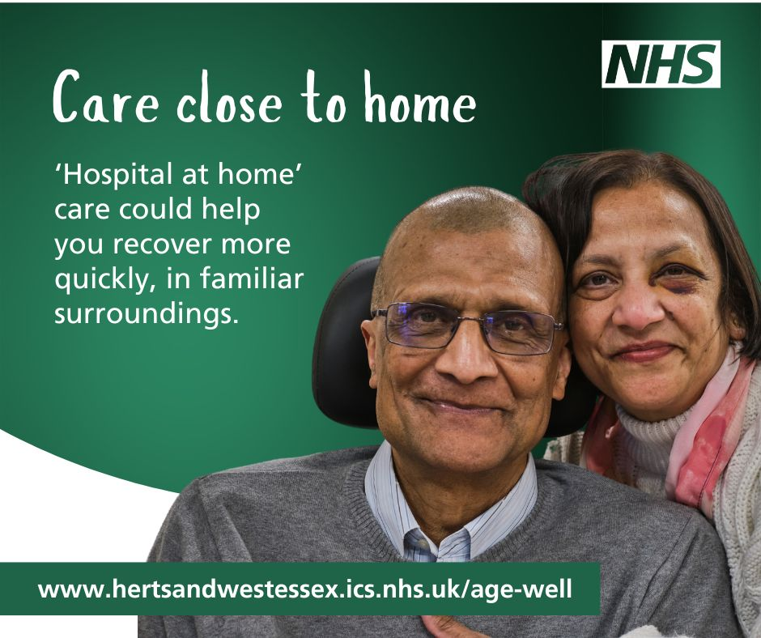
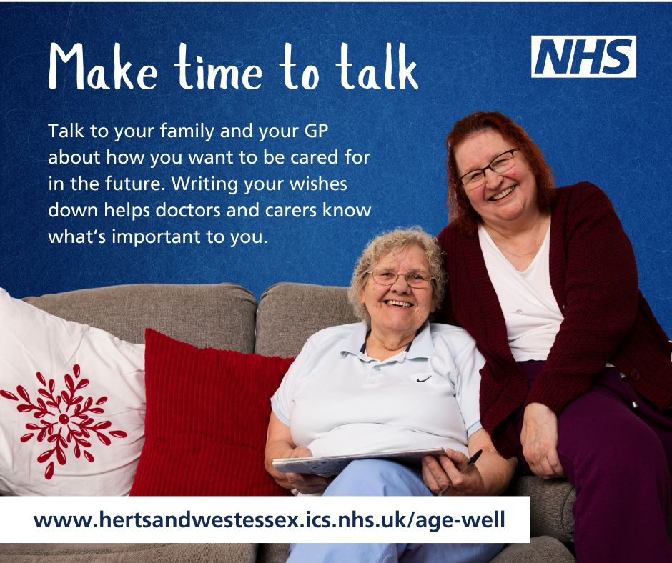
Approved social media graphics can be downloaded from the communications toolkit on the Hertfordshire and West Essex ICB website: https://www.hertsandwestessex.ics.nhs.uk/your-health-and-care/stay-well/ageing-well/frailty-communications-toolkit/

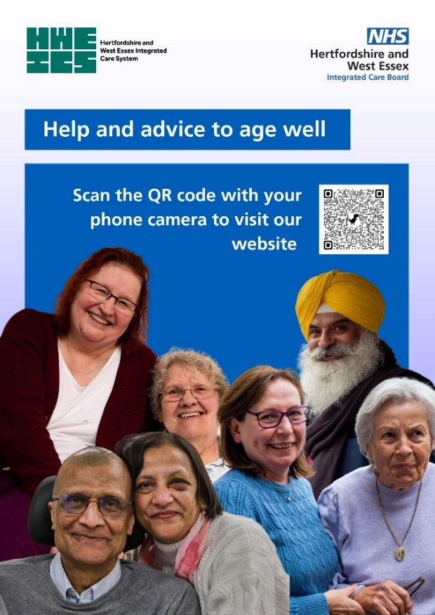
Digital screens and posters

This poster can be printed out and displayed if you want to encourage patients and carers to access information online.
Digital screens and posters can be downloaded from the communications toolkit on the Hertfordshire and West Essex ICB website: https://www.hertsandwestessex.ics.nhs.uk/your-health-and-care/stay-well/ageing-well/frailty-communications-toolkit/

Links to resources

Age UK information guides
Health professionals and groups can order printed copies of Age UK information guides. These leaflets will be useful if you are holding
any public events with older people.
Please email orders@ageuk.co.uk and state how many you'd like
of each guide and a full postal address of where you'd like them sent.
Delivery normally takes around 10 days.

- Advance decisions, advance statements and living wills
- Thinking about end of life - Getting your affairs in order and thinking about your care needs
- Your hospital stay - What to expect when you go into hospital, while you’re there and when you’re discharged
- Staying steady – how to reduce your risk of falling
- Caring for someone with dementia - Practical help and emotional support
- At home with dementia - Tips for making your home dementia friendly
- Living with dementia - From concerns and diagnosis to support and future care
- Getting help at home - What to do if you need care and support at home
- Care homes - Finding, choosing and paying for a care home
- Care homes checklist - things to look out for and questions to ask

Age UK Hertfordshire
Age UK Hertfordshire offers many services for over 50s in Hertfordshire: Age UK Hertfordshire | Our Services

Other resources
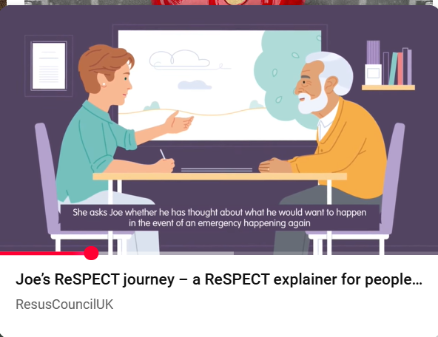
RESPECT

A 6-minute video for the public explaining the RESPECT process to support people wishes for how they would like to be cared for.

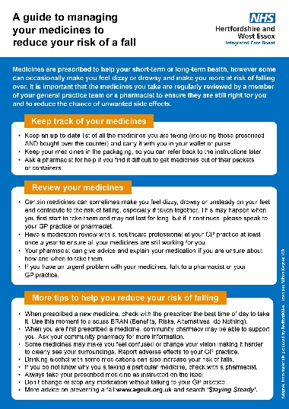
A guide to managing your medicines
to reduce your risk of a fall

Me & My Medicines, Medicines Communication Charter, It's OK to Ask – Home
More harm than good: Why more isn’t always better with older people’s medicines
https://thehealthinnovationnetwork.co.uk/programmes/medicines/polypharmacy/patient-information/
Homepage | Hospice UK& Dying Matters | Hospice UK
Start the Conversation
Health in Herts Website https://www.hertfordshire.gov.uk/services/health-in-herts/health-in-herts.aspx
Hertfordshire Healthy Hubs https://www.healthyhubs.org.uk/home.aspx
HertsHelp Website - https://www.hertshelp.net/hertshelp.aspx

Integrated Neighbourhood Teams leaflet

Getting support and care from your local
integrated neighbourhood team

What is an integrated neighbourhood team?
An integrated neighbourhood team consists of local health and care professionals and voluntary organisations who work together to support people who need extra help to stay as healthy and safe as possible. Our teams combine their expertise to offer patients the personalised support they need.
Your integrated neighbourhood team will:
- Support you to manage your long-term health condition(s).
- Make it easier for you to get the care and help you need.
- Reduce the need for you to have hospital appointments by arranging help closer to your home where possible.
- Give you the advice and support you need to live a healthier, more independent life.
Who is involved?
Integrated neighbourhood teams include doctors, nurses, pharmacists, physiotherapists, social workers, mental health practitioners, and volunteers from organisations in your local area. They are all committed to working with you and the people who support you.
How will the integrated neighbourhood team work with me?
If your GP or another healthcare professional who supports you thinks you could benefit from the team’s support, they will discuss this with you and ask for your permission to refer you to the team.
The team will work with you in a way that meets your needs. The team aims to provide:
Personalised care: A care coordinator will contact you (and/or a family member) to gather more information about your needs and develop a personalised care plan to support you.
Coordinated support: Your care coordinator will make sure that everyone who works with you has all the information they need, so you don’t need to keep repeating key information to different healthcare professionals and your care is more streamlined.
Convenient help: The team will provide services in your local area, sometimes even at home, to make life easier and more convenient.

Making sure your care is joined up
To provide you with the best care, our team members may need to share health and care information about you with each other. This will help your team to coordinate the support they give you, support safe medical decisions and person-centred care.
Your information will be shared only with your permission, and only with relevant professionals who need to know about you in order to help you. Details about you will be handled safely and securely, following strict NHS and social care confidentiality guidelines.
If you have any questions about your local integrated neighbourhood team or would like to know more about your care options, please speak to your care co-coordinator.
We’re here to make sure you get the right care and support.
Contact info:
Your GP is: Dr ** from: ** GP Practice
Your Care Coordinator is: ** from ** Integrated Neighbourhood Team
You can call xxx a on: 01010 101010 or email: **@... if you wish to discuss any aspect of your care.

