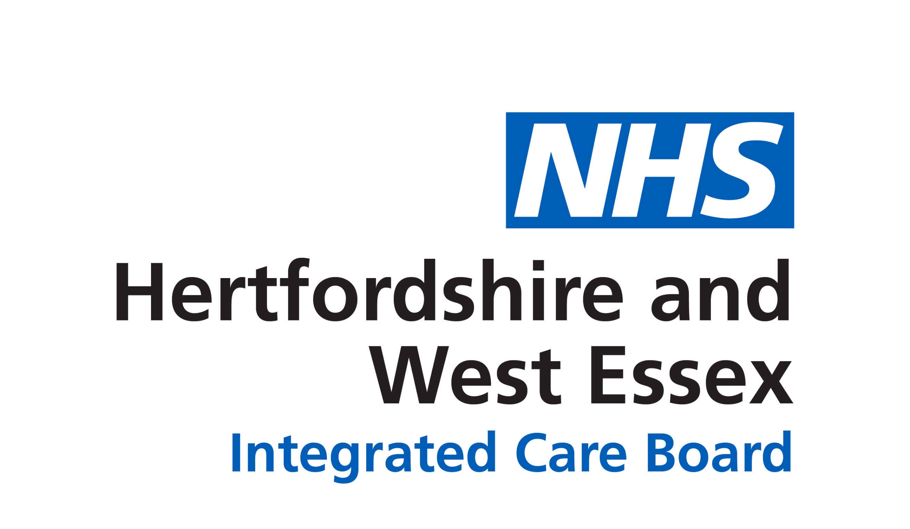
Right care, right place, right time
How to get the care you need, and
avoid a hospital visit if it’s not needed.

Most of us feel fit and healthy most of the time, but it’s important to know where to get the right advice, care and help when we don’t. Don’t put off asking for help - otherwise little things can turn into serious issues that need more complicated treatment.

There are a range of NHS services to help you get the care you need in the best place.

The NHS website is a great place to start if you have minor symptoms – you will find clear and simple self-care advice.

You can get help for many minor conditions from a pharmacy. Pharmacists will advise you and if they think it might be something more serious, they will direct you to the care you need. Most pharmacies can also provide medicines if needed for conditions including shingles and sinusitis.

If you have an ongoing health condition, contact your GP practice. If you can’t get through on the phone or online, keep trying, as appointments are made available at different times. Ask a friend or family member if you need help to contact your GP practice.
In the evening or at weekends, phone NHS 111 or visit www.111.nhs.uk Trained staff will ask about your symptoms and direct you to the best place for help. This might be at an urgent treatment centre or minor injuries unit. They can also make an appointment with a GP or nurse if you need to be seen urgently.

Why hospital is not always the right place
for your care
The local NHS is working with councils, charities and voluntary groups to help older people stay fit and well. We’re putting in place more ways to get the care you need in your own neighbourhood, so you only need to go into hospital if it’s really needed.

Hospital care will always be available for some health problems, but it's important to know that receiving care at home or in a local clinic can sometimes be better for you. Here are some reasons why:

There’s no place like home: Being at home is more comforting and less disruptive than going to hospital.

For frail older people especially, even a short stay in hospital can mean you lose mobility and muscle strength, which can make getting back to normal more challenging. Instead of a hospital stay, there are services called ‘hospital at home’ or ‘virtual wards’ which allow you to be monitored daily and receive hospital-type care in your own home. You can then be managed safely, effectively, and in accordance with your wishes in a familiar environment. All the equipment for this will be provided and explained so you don’t need to be a tech expert to use it.

Get ready to come home: If you’ve been in hospital, ask staff what practical steps your family can take to get you home safely and comfortably as soon as you are well enough. You can also ask if ‘hospital at home’ could get you home more quickly.

Planning ahead
Make choices now about what care you receive, and where you go for it. Advance Care Planning describes the conversations you have with your family and those looking after you about your future wishes and priorities. It is a way to think ahead, to describe what’s important to you and to ensure other people including health and social care professionals know your wishes.

Talking with others and writing things down in your Advance Care Plan means that your wishes are known and respected, and you are more likely to be able to experience the choices you prefer. You can always change your mind later if needed.

Things to think about include whether you’d rather be treated at home, hospital or elsewhere, and if there are any treatments you’d rather not have. Your reasons might be cultural, religious or just based on your own feelings. What matters is that you make your wishes clear, they are recorded in your care record and shared with healthcare professionals to guide decisions.


Things you can do now

Talk to family and loved ones about where and how you would like to be treated. Use an online guide or template to write an Advance Care Plan, discuss it with your GP.

Go online to www.ageuk.org.uk/health to read about a range of health topics.

Making medicines work for you
More isn’t always better with older people’s medicines.
More than 1 in 10 people aged over 65 take at least eight different
prescribed medications each week. If you take lots of medicines,
it’s important to check they are working for you.

Medicines can be vital to help manage health conditions and live well for longer; and you should not be concerned about taking large numbers of medicines if appropriately prescribed and correctly managed.

When you need to take medication, your GP, a pharmacist or other healthcare professionals involved in your care will work with you to make sure that you get the right choice of medicine at the right time. This includes understanding the benefits, risks, alternatives and considering the option of doing nothing.

Knowing how and when to take our medicines can be complicated. To get the most benefit from your medication, you should take it in exactly the way that it says on the medicine label. If you stop taking your medication – or if you stop taking it in the way it states on the label – please make an appointment with your GP Practice to talk about this. You can then make a shared decision about your medication.

It’s OK to ask
If you’re not sure what all your medicines are for, it’s important to talk to your GP practice, pharmacist or another healthcare professional to find out.

It’s OK to ask if you have questions or worries about any of the medicines you’ve been prescribed. Your GP practice might invite you to discuss your medicines, and this is a great opportunity to raise any concerns you might have.




Wasted or unused medicine
The NHS pays for every medicine it dispenses and each year spends around £300 million on medicines that are unused. Every pound wasted could have been used to treat someone else.

Please remember to:
- order your repeat medicines in good time. GP practices and pharmacies need up to a week to process requests
- if you have a smartphone, you can request a prescription on the NHS App
- check what medicines you already have at home before you order more
- tell your doctor or pharmacist if you stop taking your medication
- speak to your pharmacist if you are receiving medicines you don’t use.

Things you can do now

Talk to family and loved ones about the medicines you take and make a note of any questions you might have.
Read more on our website: www.hertsandwestessex.ics.nhs.uk/
your-medication
Find out what your medicines are for and what are the risks and benefits of taking them. Ask your GP Practice, pharmacist or another healthcare professional.

